Assignment #9: Rotational Motion II
- The mass of the earth is 5.974 x 10²⁴ kilograms. Its radius is 6.387 x 10⁶ m. The moment of inertia for a solid sphere is given by . The earth rotates once every 24 hours.
  - What is the rotational velocity of the earth (in radians per second)?

  - What is the Moment of Inertia of the earth?

  - What is the rotational kinetic energy of the earth?

- The moon orbits the earth approximately once every 28 days. Its mass is 7.36 x 10²² kg, and its orbit is in the same direction as the earth's rotation.
  - What is the orbital radius of the moon?

  - What is the total angular momentum of the earth-moon system?

  - The moon is moving away from the earth at 0.038 meters per year. How far will the moon be from the earth after 1 Billion years?

  - Use the law of conservation of angular momentum to calculate the length of a day on earth 1 billion years from now.

- Isaac is sharpening his axe on a grinding stone, using a force of 100N. The radius of the stone is 0.25 meters. The moment of inertia of the stone is 75 kgm². Initially, the wheel makes 3 rotations per second. After 20 seconds, the wheel comes to a complete stop.
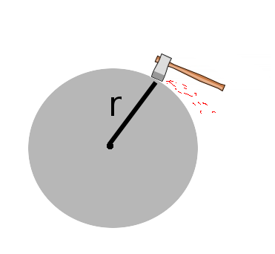
  - What was the angular acceleration of the wheel?

  - What is the torque exerted by friction?

  - What is the coefficient of friction (ignore gravity).

  - How many rotations does the wheel make before coming to a complete stop?

  - What is the speed of the wheel (in radians per second) after 7.5 seconds?

  - What is the tangential velocity of the wheel at 17.3 seconds?

